|  |  |
| --- | --- |
| Name | Anju Paul |
| Batch Code | LISUM10: 30 |
| Submission Date | 30-06-2022 |

**Deployment on Flask**

1. Select the Dataset:

The IRIS dataset from Kaggle

url: <https://gist.github.com/netj/8836201>

1. Save the Model:

Read the data, identify the features, divide it to test and rain, fit and transform the model, and save the model.

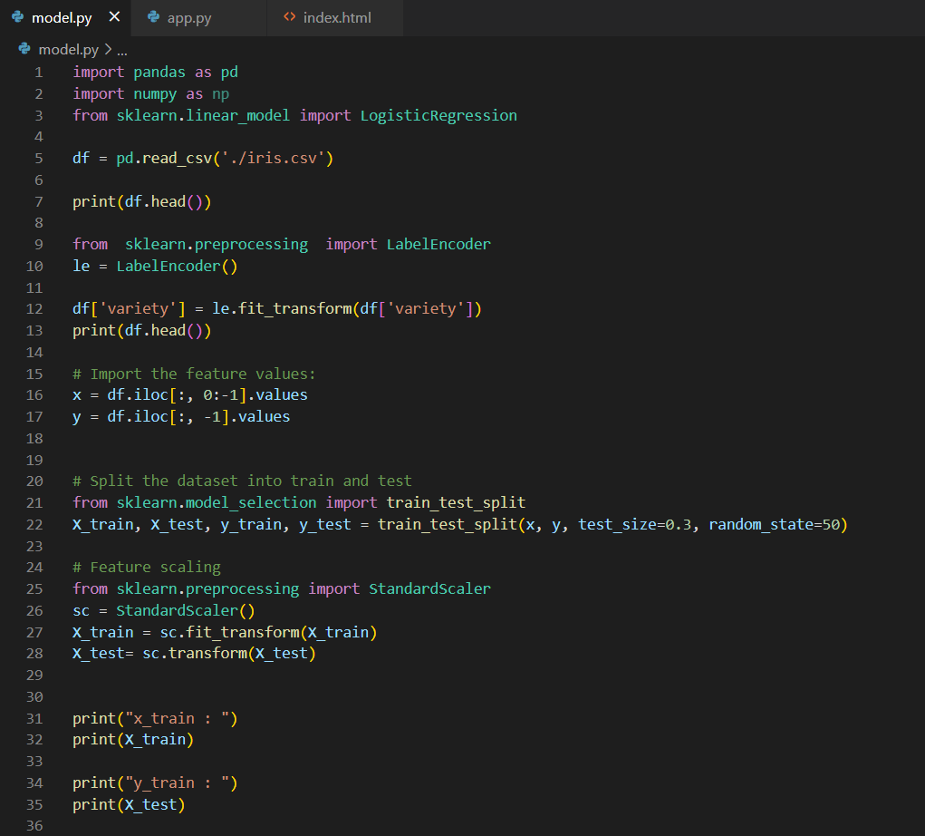

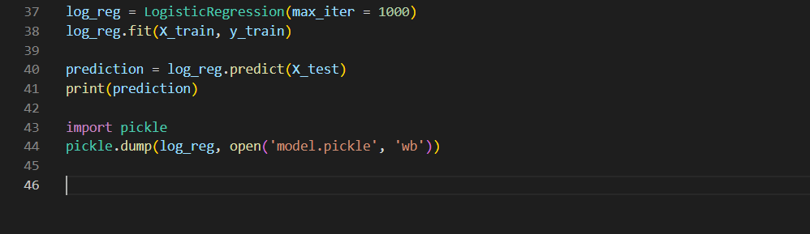

1. Deploy the model in Flask

Create an html web page to accept the inputs to identify the type of flower.

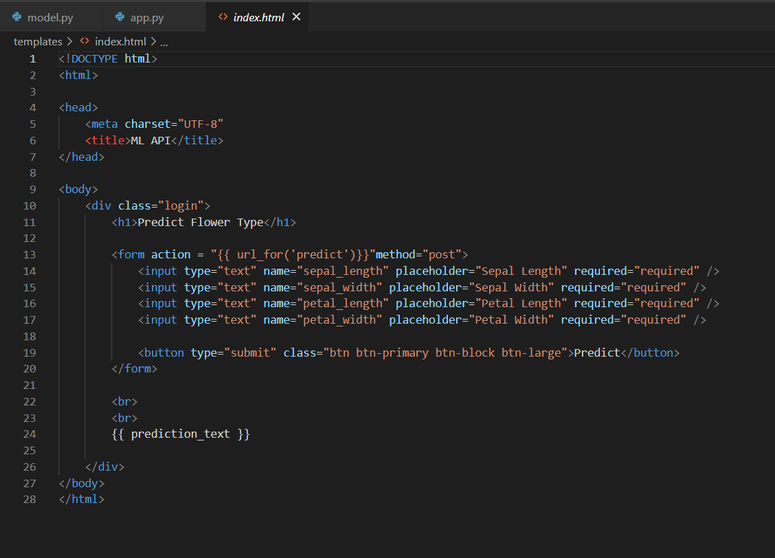

Create app.py to render the above webpage html to accept the inputs and predict the ouput using the saved model.

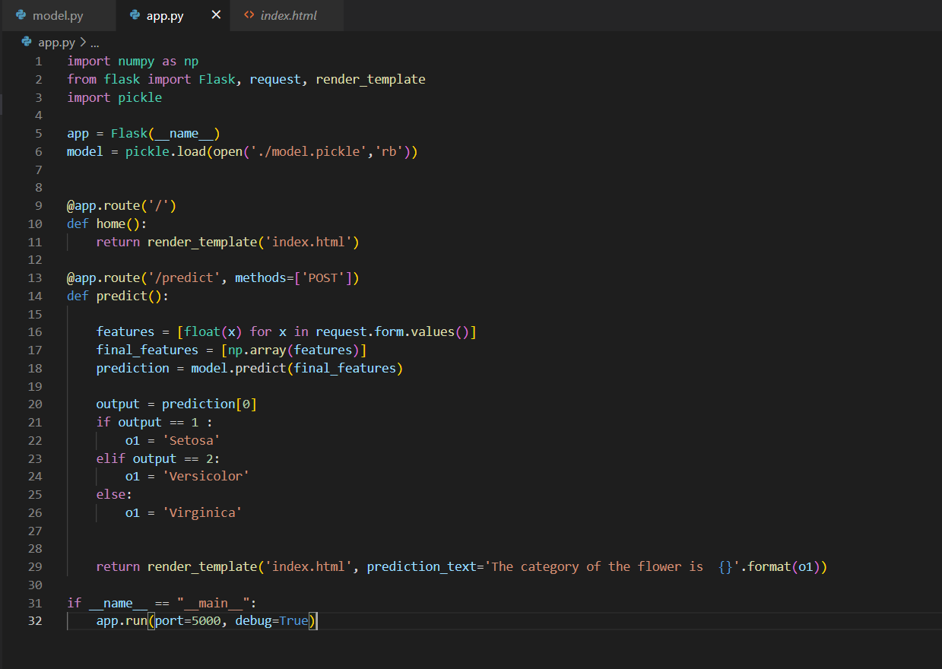

Run the app.py script

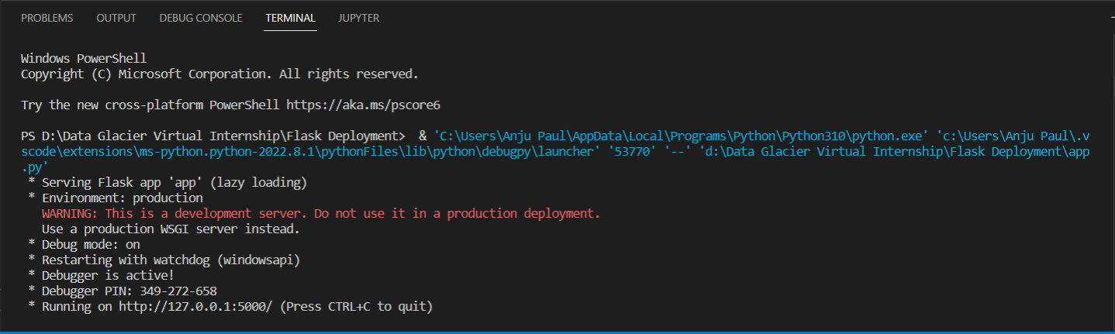

Open the url in the web browser.

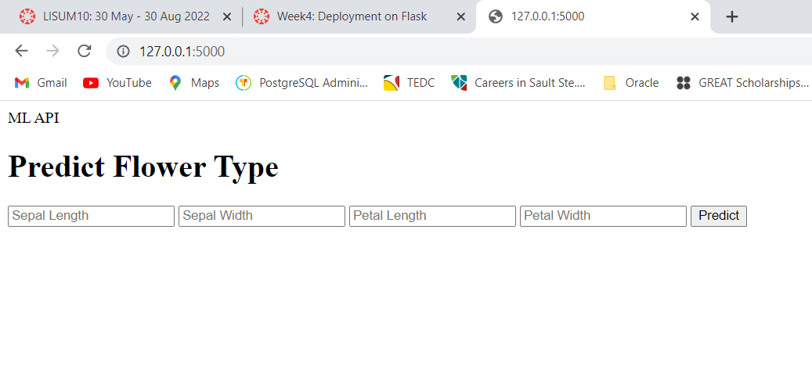

Fill in the values and click predict.

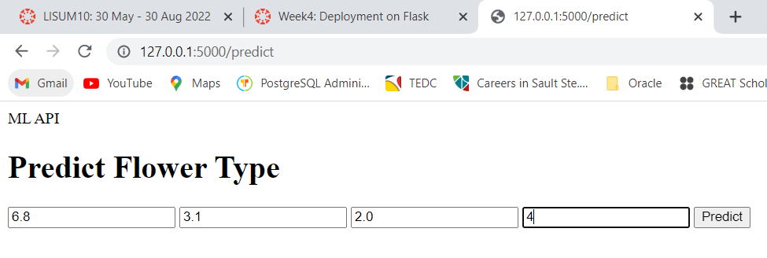The output will be as shown in the below figure.

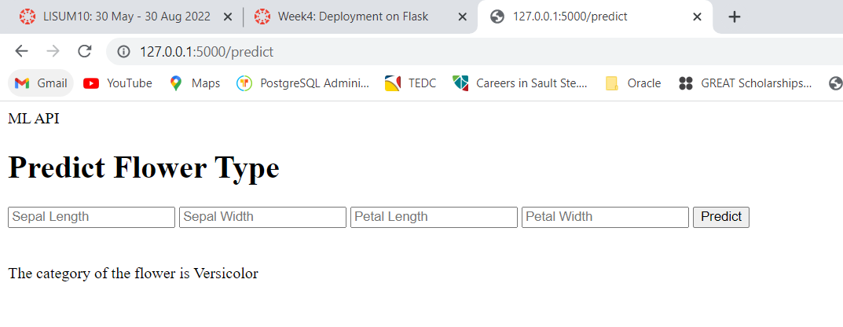

**Deployment in Heroku:**

1. Upload the scripts to the Github library

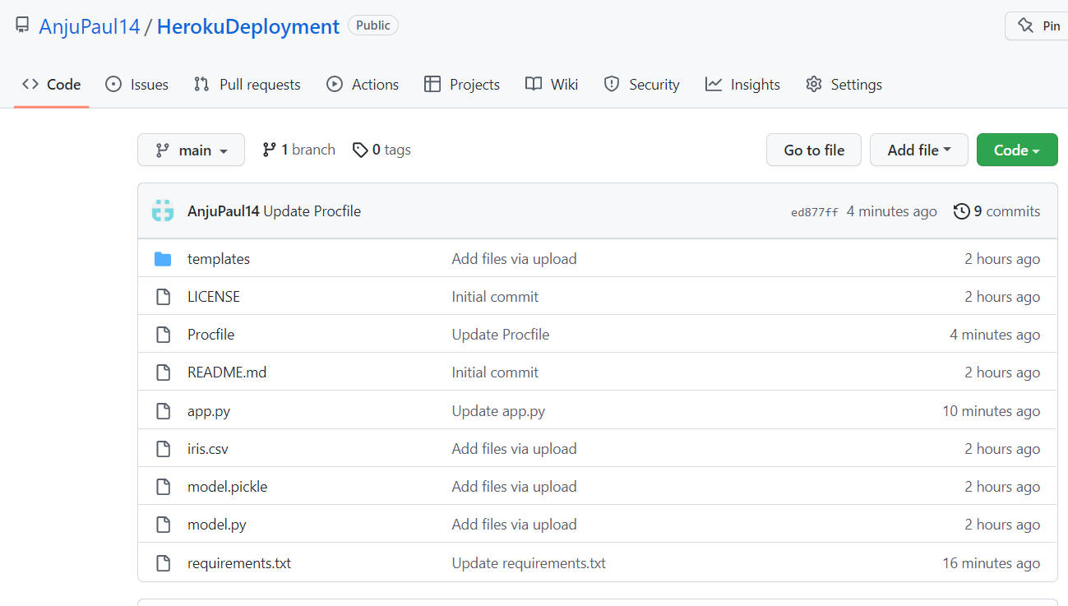

1. Create Heroku Account



1. Link the Github account to Heroku and connect the repository

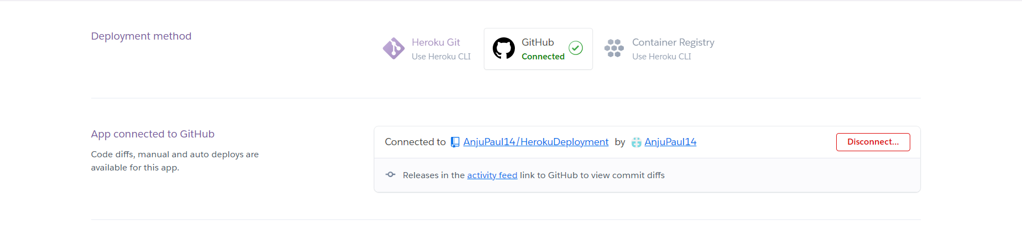

1. Deploy the Github branch

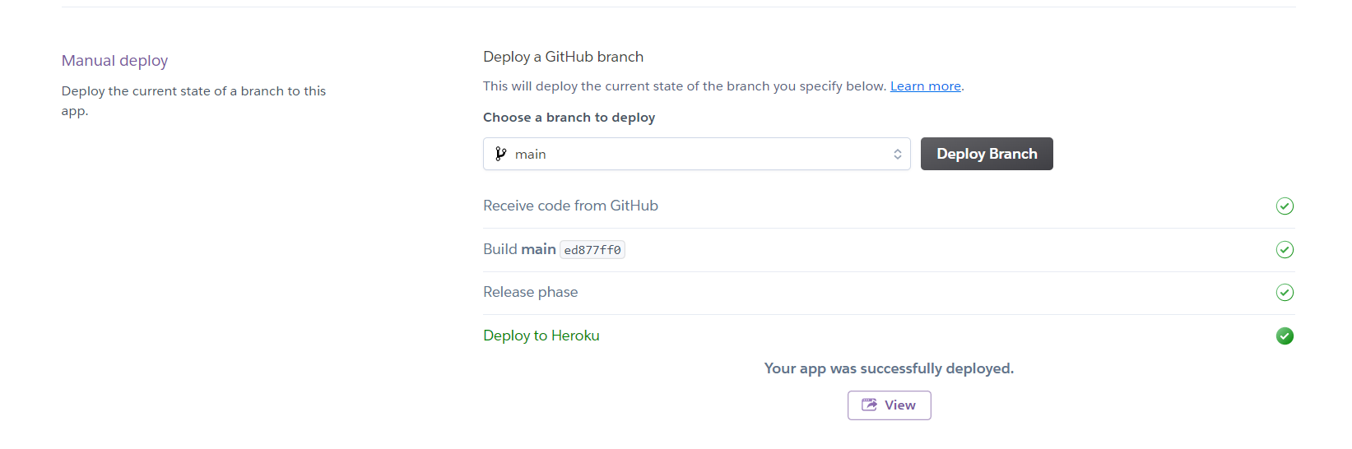

1. Test the app

url : <https://heroku-flowertype-prediction.herokuapp.com/predict>

